CONTACT INFORMATION
Thom Boulton (Blaidh Nemorlith)
Email: greenbanddruid@outlook.com
Facebook: https://www.facebook.com/BlaidhNemorlith
Twitter: https://twitter.com/GreenBandDruid
Website: http://blaidhstales.weebly.com/

Available for workshops, events and festivals.

Included in this kit:
Biography
Photos for use
Poems for articles

BIOGRAPHY
Blaidh Nemorlith (Thom Boulton) is the Poet Laureate for the City of Plymouth.
Thom spent his childhood in Dobwalls, Cornwall attending Liskeard School and Community College before studying for Bachelor of Education (with Hons) at Rolle College, Exmouth and Plymouth University. After graduation as a Primary Teacher, Thom and his wife Clare, who is also a teacher, decided to stay in Plymouth, a city they had grown to love not least for the range of opportunities it offers. Thom and Clare each combine teaching (Thom works at Plaistow Hill Infants and Nursery School in St Budeaux) with care of their young daughter.
Thom/Blaidh has been writing contemporary poetry for twelve years. He credits his polificity to his love of words and his interest in the world. At 17 Blaidh began to write observational poetry both as a way to deal with the world and because of the joy of the process. He and several of his friends became actively involved in AllPoetry.com and would meet regularly to share their creations. During his university career, when not busy with assignments, Blaidh would listen to the Poetry Off the Shelf podcast which he believes greatly helped his development as a writer. He continued to post on AllPoetry.com and began to win and be placed in various contests on the site. In 2011, whilst experimenting with different characters, Blaidh wrote a piece called 'Overly Stimulated' (under the guise of Gallimaufry the Ineffable) which was feature in the first issue of the Railroad Poetry Project: available at http://issuu.com/railroadpoetryproject/docs/issueone. In 2015 beginning his biggest project to date Blaidh launched the Blaidh's Tales website (http://blaidhstales.weebly.com/) in order to post new pieces. The focus here is folklore and fairy tales for adults and the first 60 tales were published at the end of 2015 in Blaidh’s first poetry book. Since then, Blaidh has, in collaboration with several others, produced and published several children’s books: Malerblatt’s Tree was released on New Year’s Day 2016 and South West Legends (illustrated by Anthony Rollinson) is on sale at three locations on Dartmoor. Blaidh’s poem ‘Alone in Blue’ was published in the Plymouth Herald alongside an interview with Blaidh (8 Oct 2016).
Following his instatement as Plymouth Poet Laureate Blaidh performed during the Plymouth Literature Festival 2016 at various events across the city. He was placed as a finalist during the Flash Fiction event, read some of his work at The Word, Twin Sounds (Brest/Plymouth exchange) and The Big Open Mic Night. With his creative collaborator, Dorian Sounde, Blaidh performed at the auditorium theatre, Plymouth Athenaeum, with a show of his own crafting entitled In The Darkly Woods. The show was comprised of retelling of dark fairy tales from Europe, folklore poetry about Plymouth and ended with some of Blaidh’s Tales which had been converted into songs.
Blaidh is a regular attendee of Cross Country Writers, a Plymouth based poetry and prose group which meets once a month and is a supportive environment in which participants can share their work. If you want to attend CCW then contact Kenny or William via their facebook page or twitter account.

PHOTOS FOR USE
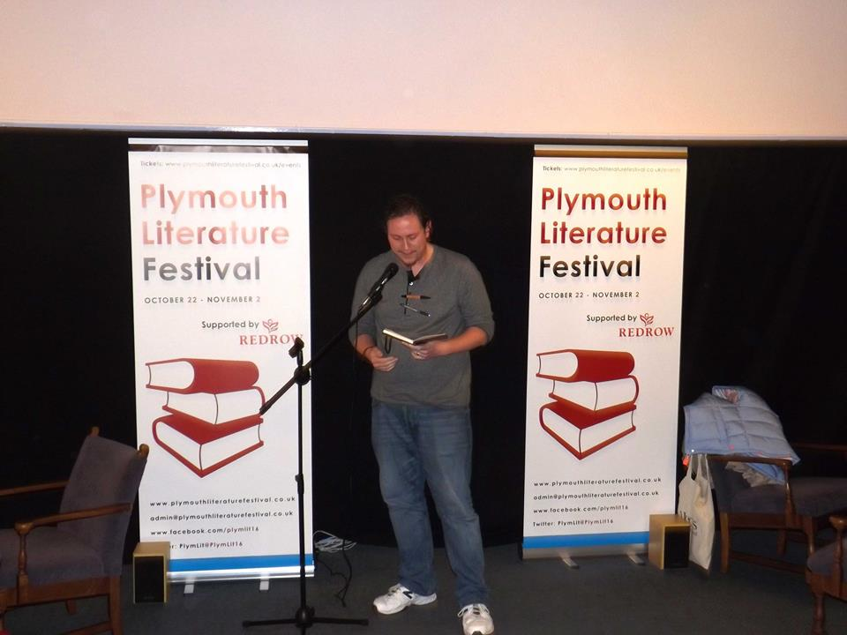
Profile picture from twitter account and picture taken as finalist at Flash Fiction Comp (PlymLit’16)
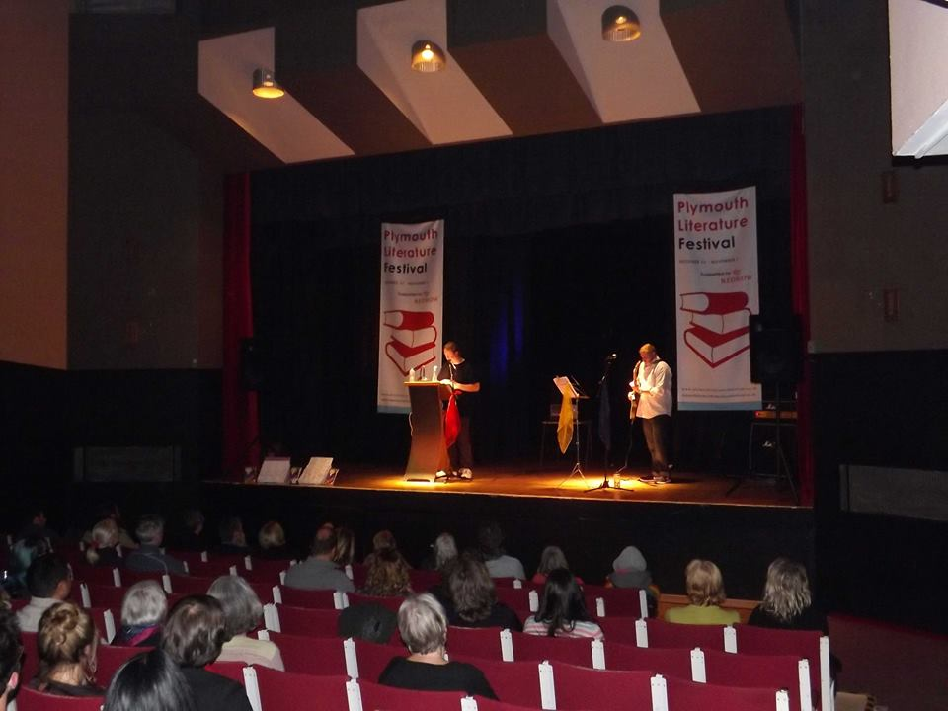
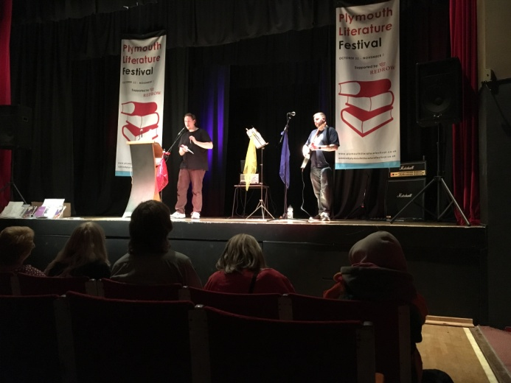
Pictures taken at In The Darkly Woods (adult folklore/poetry and music) during PlymLit’16
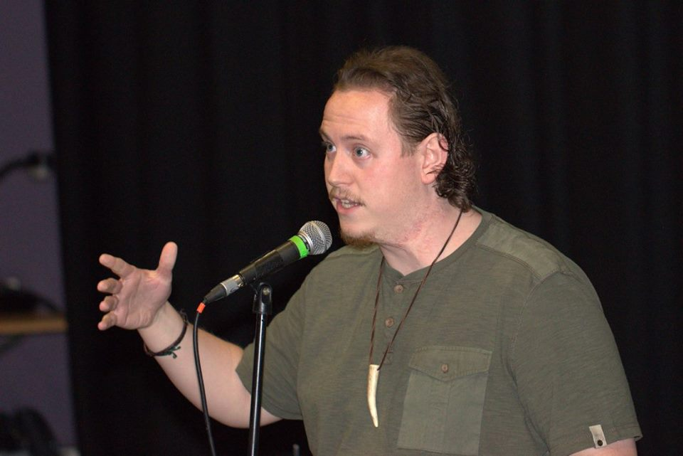

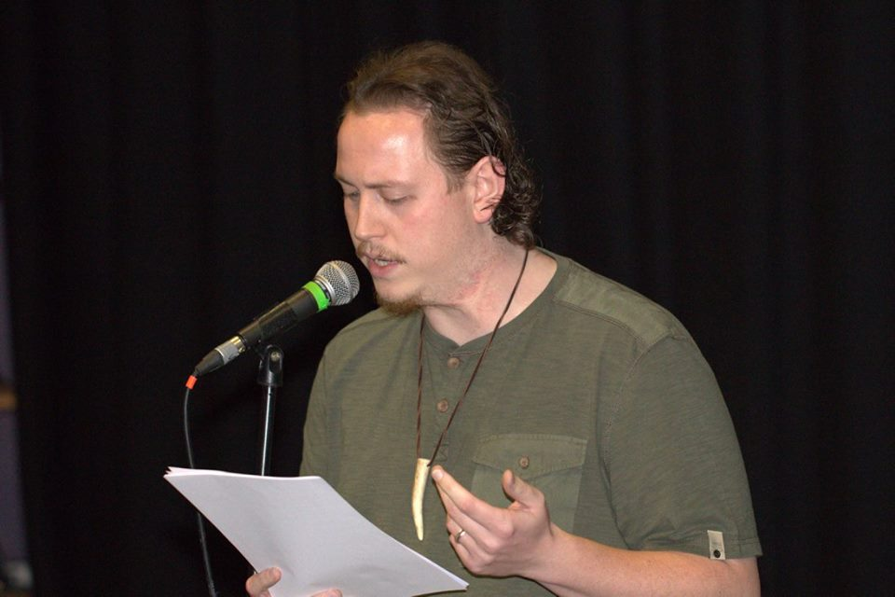
Pictures taken at Twin Sounds (Brest/Plymouth writer exchange) during PlymLit’16
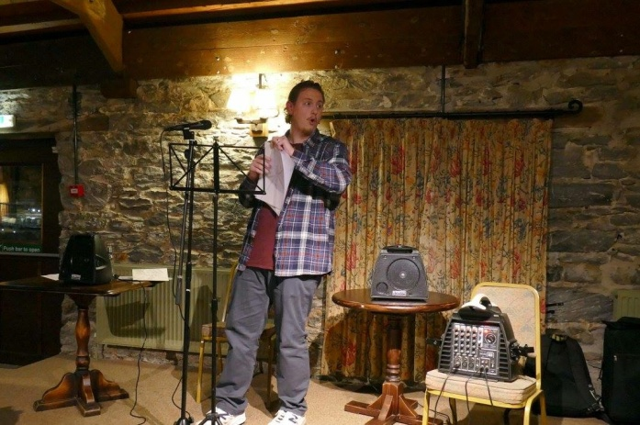

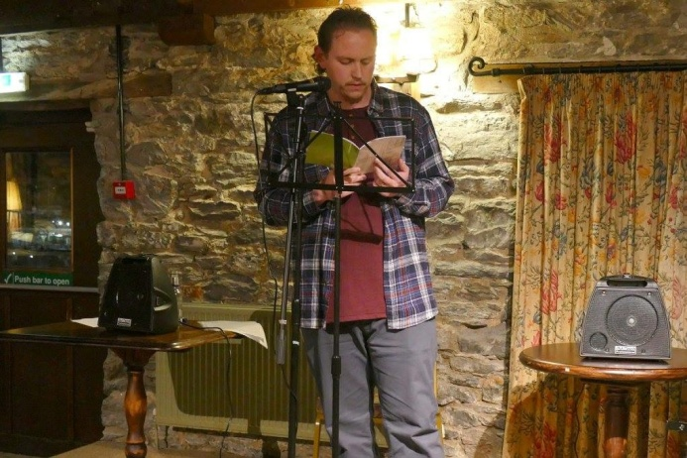
Pictures taken at The Word (evening of poetry/spoken word) during PlymLit’16
WORKS AVAILABLE FOR PUBLISHING

Where does the bus go

when it doesn’t arrive on time?

Wait in the rain
with face pressed hard against
plastic pane
reading that advert for latest Anne Hathaway film
over and over
wondering where
that bus has got to
and why it is terribly late...

It has not met grizzly fate.
No, it has not,
bus has it’s own venture
before rescuing passenger
from propped up purgatory shelter.

It has gone to Disneyland
and ridden all the rides,
queued for hours
to enjoy the madness of
Thunder Mountain.

It is sat in a local bar
meeting an old friend,
discussing the old days of conductors
of which it misses terribly.

It is meditating in Tibet.
Contemplating the crisis
of Dalia Lama and China
and mulling over how
it can bring about
world peace.

It is writing a new cookbook
called Grease and Diesel based dishes for Automobiles on a budget,
so far, it only has two chapters.

It is protesting unlimited University fees,
Apartheid (yes it can travel back in time),
It is singing along to Jimmi Hendrix
at Yasgur’s Farm
and taking stock
of the transcendental vibes
being puffed out into a plume.

It is anywhere but where you want it
because it does not belong to you,
the bus is free, and extremely busy.

How dare you demand it to be on time.
How dare you limit it and judge
it’s life choices.

When did you become the only individual on that busses passenger list?
And in mind bending,
spoon bending moment,
you realise, there is no list.

No doorman,
no velvet rope,
and the VIP area is merely a wide seat with your own buzzing button.

Change the laws of physics
if you want the bus on time,
If you can’t, learn a virtue,
Or a card game,
maybe... patience...?

Line, Form and Repetition
Ballerina, floating effortlessly
upon the floor,
she twirls, she is perfection.
They adore her as she lifts her leg,
kicks high,
for she is everything they ever wanted
to be.
Amongst the crowd of long lost dreamers,
her mother weeps a tear,
but not for her charming daughter,
no, for the life she ought to have had, and it drives her mad.
If only she hadn’t met drink, or boys,
her own maternal feeder
mumbled that line constantly,
as she peered down at her,
from disappointed eyes.
Now she lives through this one,
and she won’t let her fail.
Pushing, ever pushing.
If she is to succeed,
she must follow creed,
and when her splintered toes bleed,
she must persevere.

For it’s what feeds her mother,
sustains her incessant need to fulfil unaccomplished ambitions.
If Freud were dead,
he’d be rolling in his grave,
her sexual frustrations,
are projections of rejections
forced upon her,
by her supposed carer,
and now she cares too much,
to the point of self-destruct,
where she will end up killing her child…
Manslaughter
from the malintent, malcontent.
Because she leant too hard upon her,
never let up.
And for one second she realises this,
and for one second she conjures hope,
that she could break free from this dope and instead,
break this tradition of,
artistic abuse,
but, it is only a second,
one of many thousands she endures
in her hollow life,
and instead, she returns to her comfort,
as her child,
once again,
kicks high.

Filthy Liars
I hate liars
Dirty fabricators whose filth
spews forth
from mouth to ear
Those who fear honesty
and integrity
Those who'd much rather hide reality
for either their own gains
or worse
for no reason at all.
I hate casual liars
those that drop an untruth into a situation
they who lack ambition
and passion
and so, must smash and absorb yours
break your back, stab it and spin
and that's just the begin-ning...
I hate the gymnastics performed
by those who flip in mind
until they find
a reality or position they feel more comfortable with
I hate the fake smiles of interest
and false eyelashes of confidence
I hate the facade of mucho-macho
and the unnecessary consonance
I despise the greed fuelled mumbles
and the green eyed stares
I despise the continuing lies
that wear
friendships
down
I despise the denial from the poor
and the hidden secrets of those of wealth
I despise you lying to me but I hate it more when you lie to yourself
I hate the traitors of state and those in charge of our fate
I hate the lies that save billions
but cost us millions of pounds or of souls

I reject stereotypical roles
and this notion of racism
I refuse to acknowledge anything that causes a schism
If I deny you it then it cannot be
I'm not afraid to stand up
for you and for me
I refuse to fall in line to this 'game'
you have made
I reject this idea that it all comes down to being paid
This life is beautiful,
a chance of improbable feat
I will protect it from those who falsify
and cheat
I will be a modern day worthy
and encourage the truth
and help build a future
by educating the youth
that this nation will crumble
when doused in protestations
I have aspirations, for honest foundations
...and I beg you to help me,
help me be heard
so that hate
and liar
can become no longer used words.

